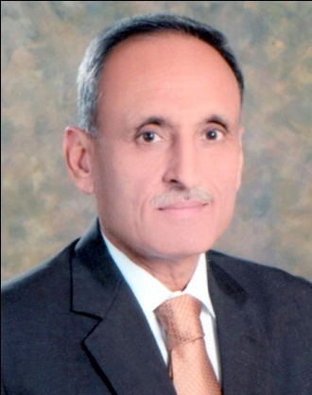

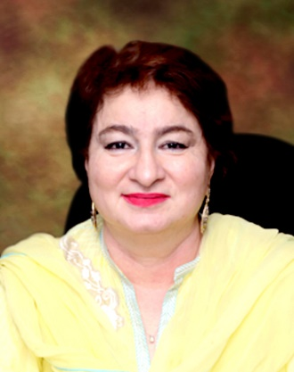

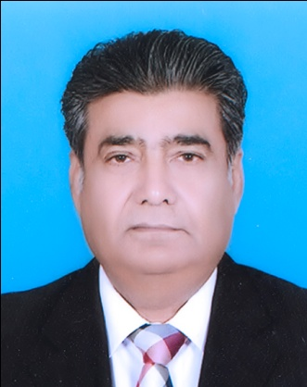

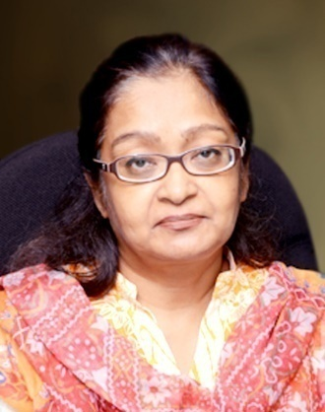

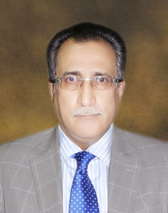

|  |  |  |  |  |
| --- | --- | --- | --- | --- |
| Name of officer | DR. MUHAMMAD IRSHAD | | | |
| Current Posting | Chief Commissioner IR, LTU | | CTP | 13th |
| Education Qualification | MBBS, LLB, MBA (Finance), Post Graduate Diploma in public Administration | | STP | 13th |
| Date/year of posting in LTU | 11-07-2014 | Experience | |  |

|  |  |  |  |  |
| --- | --- | --- | --- | --- |
| Name of officer | NAUSHEEN AMJAD | | | |
| Current Posting | COMMISSIONER IR, ZONE-I | | CTP | 13th |
| Education Qualification | M.A. (Economics) | | STP | 13th |
| Date/year of posting in LTU | 2010 | Experience | | 29 Years |

|  |  |  |  |  |
| --- | --- | --- | --- | --- |
| Name of officer | MUHAMMAD MUZAFFAR KHAN LASHARI | | | |
| Current Posting | COMMISSIONER IR, ZONE-IV | | CTP | 13th |
| Education Qualification | MA: English, Pol. Science DTL, LLM | | STP | 13th |
| Date/year of posting in LTU |  | Experience | | 29 Years |

|  |  |  |  |  |
| --- | --- | --- | --- | --- |
| Name of officer | SEEMA SHAKIL | | | |
| Current Posting | COMMISSIONER IR, ZONE-II | | CTP | 14th |
| Education Qualification | M.Sc | | STP | 14th |
| Date/year of posting in LTU | 2012 | Experience | | 27 Years |

|  |  |  |  |  |
| --- | --- | --- | --- | --- |
| Name of officer | DR. MUHAMMAD ALI KHAN | | | |
| Current Posting | CIR, Zone-III, LTU, Khi | | CTP | 16th |
| Education Qualification | Ph.D (Law)  LL.M | | STP | 16th |
| Date/year of posting in LTU | 01-08-2013 | Experience | | 28 years |

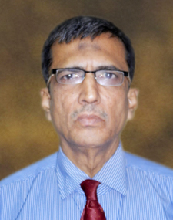

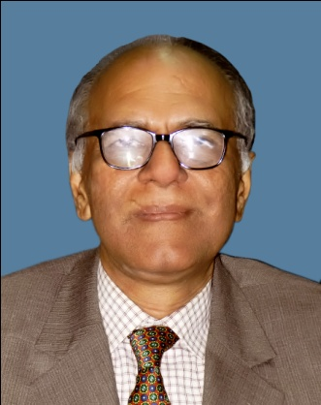

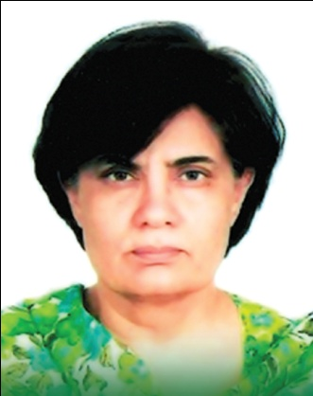

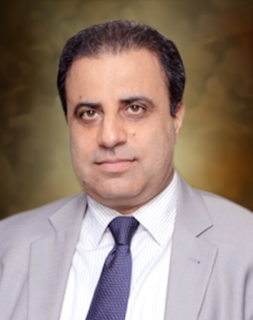

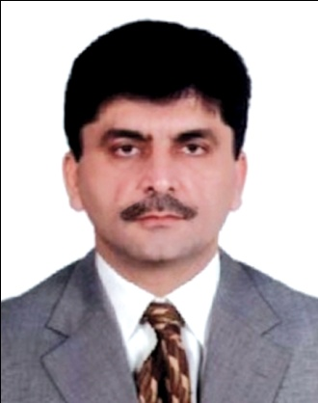

|  |  |  |  |  |
| --- | --- | --- | --- | --- |
| Name of officer | MUHAMMAD UMAR FAROOQ | | | |
| Current Posting | Commissioner IR, LTU | | CTP | 10th |
| Education Qualification | M.A. (Political Science) | | STP | 10th |
| Date/year of posting in LTU |  | Experience | | 32 Years |

|  |  |  |  |  |
| --- | --- | --- | --- | --- |
| Name of officer | DR. FARRUKH ANSARI | | | |
| Current Posting | COMMISSIONER IR, (HRM) | | CTP | 15th |
| Education Qualification | MBBS, LLM | | STP | 15th |
| Date/year of posting in LTU | SEPTEMBER, 2004 | Experience | | 26 Years |

|  |  |  |  |  |
| --- | --- | --- | --- | --- |
| Name of officer | NAHEED AZHAR | | | |
| Current Posting | COMMISSIONER IR, (IP/TFD) | | CTP | 12th |
| Education Qualification | PhD Candidate Public Policy/ Intl. Dev. | | STP | 12th |
| Date/year of posting in LTU | 29th October, 2013 | Experience | | 26 Years |

|  |  |  |  |  |
| --- | --- | --- | --- | --- |
| Name of officer | SHAHID IQBAL BALOCH | | | |
| Current Posting | ADCIR, RANGE-A (AUDIT), Z-IV | | CTP | 20th |
| Education Qualification | L.L.M, M.A. (POLITICAL SCIENCE) B.E. (CIVIL) | | STP | 20th |
| Date/year of posting in LTU | 01-11-2002 | Experience | | 22 Years |

|  |  |  |  |  |
| --- | --- | --- | --- | --- |
| Name of officer | YOUSIF HYDER SHAIKH | | | |
| Current Posting | Addl. Commissioner IR(HRM) | | CTP | 21st |
| Education Qualification | MPA(Economic Policy), LLB, BE (Electrical Engg.) | | STP | 21st |
| Date/year of posting in LTU | 07-07-2008 | Experience | | 21 year |

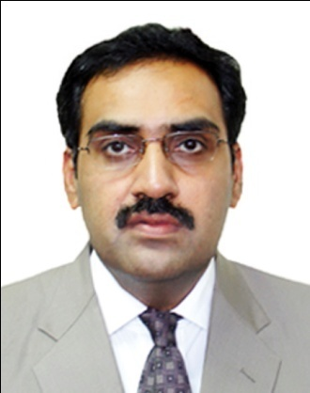

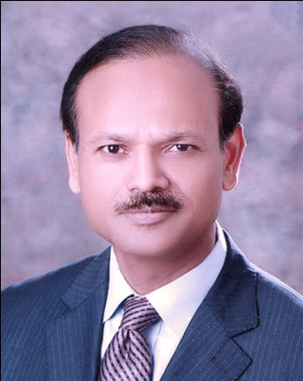

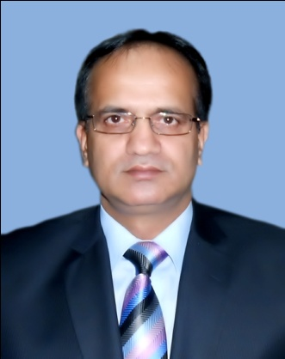

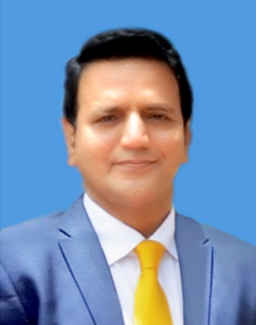

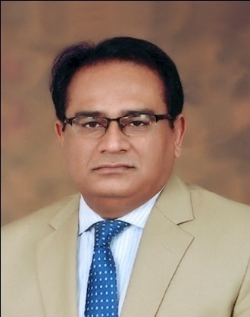

|  |  |  |  |  |
| --- | --- | --- | --- | --- |
| Name of officer | FAISAL ROUF MEMON | | | |
| Current Posting | ADCIR, Range-A (E&C) Zone-III | | CTP | 25th |
| Education Qualification | LLM, BE (Civil) | | STP | 26th |
| Date/year of posting in LTU | 2007 | Experience | | 17 Years |

|  |  |  |  |  |
| --- | --- | --- | --- | --- |
| Name of officer | SYED SHAKEEL AHMED | | | |
| Current Posting | ADC, RANGE-B (AUDIT), Z-II | | CTP | 25th |
| Educational Qualification | MBA (Finance) | | STP | 25th |
| Date/year of posting in LTU | February 2009 | Experience | | 17 years with the FBR |

|  |  |  |  |  |
| --- | --- | --- | --- | --- |
| Name of officer | CH. MUHAMMAD ANWAR | | | |
| Current Posting | ADCIR, RANGE-B (E&C), Z-III | | CTP | 26th |
| Education Qualification | B.Sc (Civil Engg. (Hons) | | STP | 26th |
| Date/year of posting in LTU | 17-09-2012 | Experience | | 15 Years |

|  |  |  |  |  |
| --- | --- | --- | --- | --- |
| Name of officer | SHAKEEL AHMAD KASANA | | | |
| Current Posting | ADC (HQ) | | CTP | 26th |
| Education Qualification | MBA (IBA) Punjab University, MSc (Development Economic), SOAS (University of London) UK | | STP | 26th |
| Date/year of posting in LTU | 2006 | Experience | | 16 Years |

|  |  |  |  |  |
| --- | --- | --- | --- | --- |
| Name of officer | RAFIQUE UR REHMAN | | | |
| Current Posting | ADCIR (IP/TFD) DIVISION | | CTP | 27th |
| Education Qualification | B.E. :Civil), MSc: (International Development (UK) MSc: Rural Development (UK-PK) MSc: Economics (PK) | | STP | 27th |
| Date/year of posting in LTU | 2013 | Experience | | 15 Years |

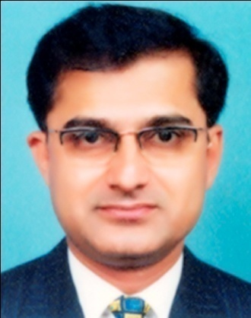

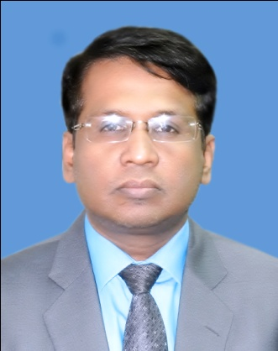



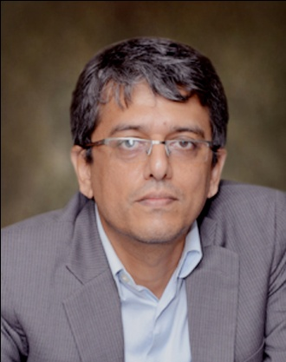

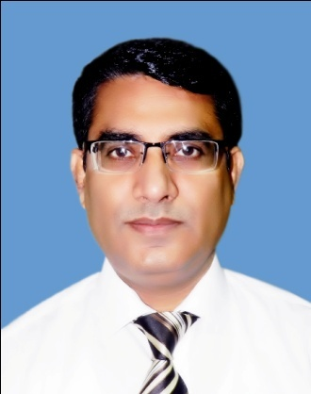

|  |  |  |  |  |
| --- | --- | --- | --- | --- |
| Name of officer | GIRDHARI MAL | | | |
| Current Posting | ADCIR, E&C Range-B, Zone-IV | | CTP | 28th |
| Education Qualification | BE, MST | | STP | 28th |
| Date/year of posting in LTU | 2008 | Experience | | 15 year |

|  |  |  |  |  |
| --- | --- | --- | --- | --- |
| Name of officer | ABDUL HAFEEZ | | | |
| Current Posting | ADCIR, RANGE-B (AUDIT), Z-III | | CTP | 28th |
| Education Qualification | M.Sc: Geography M.A: English | | STP | 28th |
| Date/year of posting in LTU | 27-02-2014 | Experience | | 14 Years |

|  |  |  |  |  |
| --- | --- | --- | --- | --- |
| Name of officer | ZULFIQAR ALI MEMON | | | |
| Current Posting | ADCIR, RANGE-A (AUDIT), Z-III | | CTP | 28th |
| Education Qualification | M.B.A., L.L.B | | STP | 28th |
| Date/year of posting in LTU | 2011 | Experience | | 14 Years |

|  |  |  |  |  |
| --- | --- | --- | --- | --- |
| Name of officer | ZIA AGRO | | | |
| Current Posting | ADCIR, Range-A (Audit), Zone-II | | CTP | 28th |
| Education Qualification | B.E (Electrical), MST | | STP |  |
| Date/year of posting in LTU | 2008 | Experience | | 15Years |

|  |  |  |  |  |
| --- | --- | --- | --- | --- |
| Name of officer | TARIQ HUSSAIN SHAIKH | | | |
| Current Posting | ADCIR, (E&C) Range-A, Zone-IV | | CTP | 28th |
| Education Qualification | MA, LLB | | STP | 28th |
| Date/year of posting in LTU | 02-03-2012 | Experience | | 15 years |

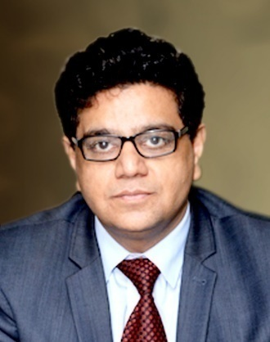

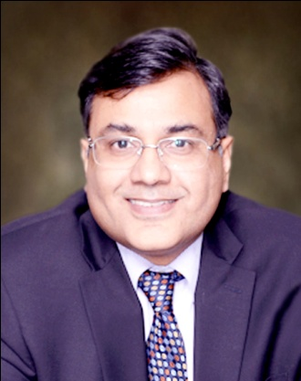

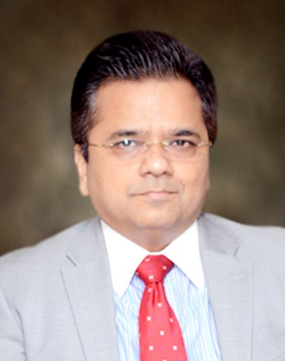

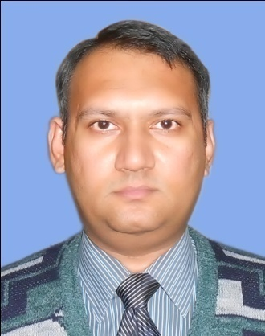

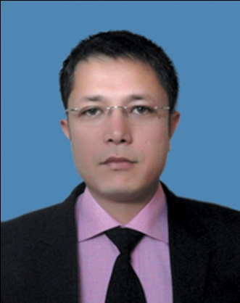

|  |  |  |  |  |
| --- | --- | --- | --- | --- |
| Name of officer | DR. NAJEEBULLAH | | | |
| Current Posting | ADCIR, RANGE-A (E&C) ZONE-I | | CTP | 29th |
| Education Qualification | MBBS, MBA | | STP | 29th |
| Date/year of posting in LTU | 2009 | Experience | | 12 Years |

|  |  |  |  |  |
| --- | --- | --- | --- | --- |
| Name of officer | JAVED IQBAL | | | |
| Current Posting | ADCIR, RANGE-B (AUDIT), Z-I | | CTP | 29th |
| Education Qualification | B.Sc (Civil Engg) | | STP | 29th |
| Date/year of posting in LTU | 2014 | Experience | | 12 Years |

|  |  |  |  |  |
| --- | --- | --- | --- | --- |
| Name of officer | ZAFAR RAFIQUE | | | |
| Current Posting | DCIR (Hqs), Zone-II | | CTP | 23th |
| Education Qualification | PhD (ABD), MILE, MBA | | STP | 26th |
| Date/year of posting in LTU | 02-09-2013 | Experience | | 16 Year |

|  |  |  |  |  |
| --- | --- | --- | --- | --- |
| Name of officer | FOUZ KHALID KHAN | | | |
| Current Posting | DCIR, Zone-III | | CTP | 27th |
| Education Qualification | B.E., B.Sc, PGDPA, MAS, MBA, MPP | | STP | 27th |
| Date/year of posting in LTU | May, 2013 | Experience | | 15 Years |

|  |  |  |  |  |
| --- | --- | --- | --- | --- |
| Name of officer | AJAZ HUSSAIN | | | |
| Current Posting | DCIR, UNIT-2 (AUDIT), ZONE-III | | CTP | 30th |
| Education Qualification | MA (Economics) | | STP | 30th |
| Date/year of posting in LTU | January, 2012 | Experience | | 5 Years |

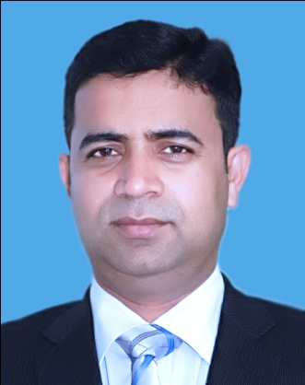

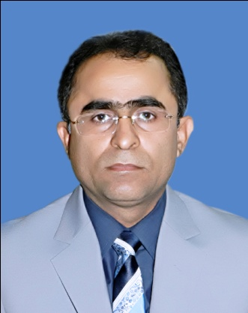



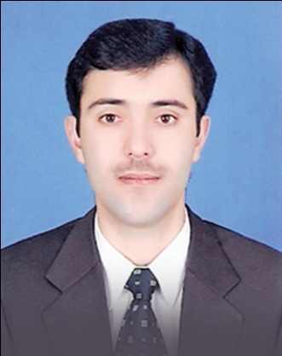

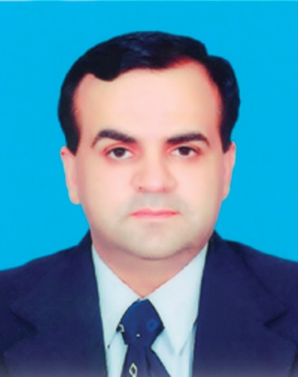

|  |  |  |  |  |
| --- | --- | --- | --- | --- |
| Name of officer | MUHAMMAD AMIN QURESHI | | | |
| Current Posting | DCIR, UNIT-2 (AUDIT), Z-I | | CTP | 31st |
| Education Qualification | M.Sc (Maths) M.B.A. (Tax Management) | | STP |  |
| Date/year of posting in LTU | March, 2012 | Experience | | 10 Years |

|  |  |  |  |  |
| --- | --- | --- | --- | --- |
| Name of officer | Abdul Wahid Shar | | | |
| Current Posting | DCIR, Unit-1 (Audit), Zone-II | | CTP | 32nd |
| Education Qualification | M.Sc (Chemistry)  M.B.A. (Tax Management) | | STP |  |
| Date/year of posting in LTU | December, 2012 | Experience | | 8 Years |

|  |  |  |  |  |
| --- | --- | --- | --- | --- |
| Name of officer | ABDUL QADEER ABBASI | | | |
| Current Posting | DCIR, UNIT-3 (E&C), ZONE-I | | CTP | 32nd |
| Education Qualification | MBBS, MBA (Tax Management) | | STP |  |
| Date/year of posting in LTU | September, 2014 | Experience | | 10 Years |

|  |  |  |  |  |
| --- | --- | --- | --- | --- |
| Name of officer | ABDUL SALAAM KHAN | | | |
| Current Posting | DCIR, UNIT-2 (E&C), ZONE-I | | CTP | 32nd |
| Education Qualification | MA (Pak), MBA (Pak) MA (UK) | | STP |  |
| Date/year of posting in LTU | 06-03-2014 | Experience | | 10 Years |

|  |  |  |  |  |
| --- | --- | --- | --- | --- |
| Name of officer | IMRAN ALI SHAIKH | | | |
| Current Posting |  | | CTP |  |
| Education Qualification |  | | STP |  |
| Date/year of posting in LTU |  | Experience | |  |

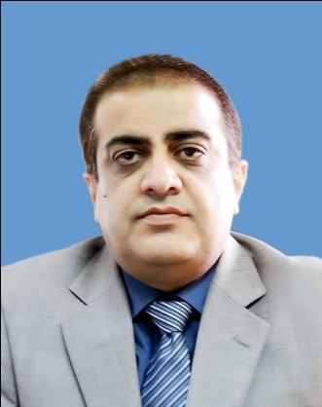

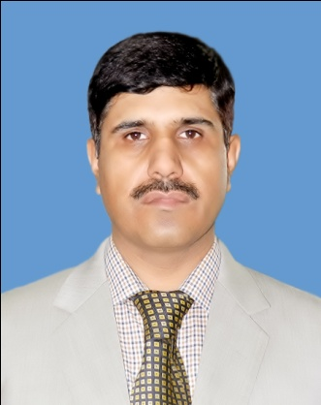



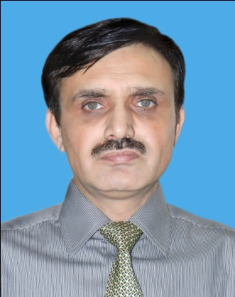

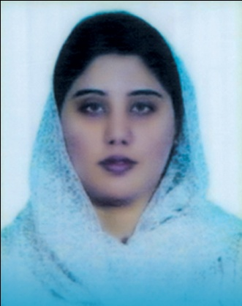

|  |  |  |  |  |
| --- | --- | --- | --- | --- |
| Name of officer | MOHSIN ALI SHAH | | | |
| Current Posting | DCIR, UNIT-4 (E&C) ZONE-II | | CTP | - |
| Education Qualification | M.Com | | STP | - |
| Date/year of posting in LTU | 24-09-2014 | Experience | | 17 Years |

|  |  |  |  |  |
| --- | --- | --- | --- | --- |
| Name of officer | AMIN ULLAH KAKAR | | | |
| Current Posting | DCIR, Unit-3 & 4 (Audit), Zone-IV | | CTP | ITO BATCH 2005 |
| Education Qualification | MA, LLB | | STP |  |
| Date/year of posting in LTU | 2013 | Experience | | 9 Years |

|  |  |  |  |  |
| --- | --- | --- | --- | --- |
| Name of officer | NASEEBULLAH | | | |
| Current Posting | DCIR, UNIT-4 (AUDIT) ZONE-III | | CTP | 35th |
| Education Qualification | L.L.B M.A. (Political Science) | | STP | 35th |
| Date/year of posting in LTU | 19-09-2010 | Experience | | 7 Years |

|  |  |  |  |  |
| --- | --- | --- | --- | --- |
| Name of officer | NISAR AHMED BURKI | | | |
| Current Posting | DCIR, UNIT-2 (AUDIT), ZONE-IV | | CTP | 33rd |
| Education Qualification | M.A. (History) | | STP | 33rd |
| Date/year of posting in LTU | September, 2014 | Experience | | 7 Years |

|  |  |  |  |  |
| --- | --- | --- | --- | --- |
| Name of officer | SADIA ALI AKRAM | | | |
| Current Posting | DCIR, UNIT-1(AUDIT) ZONE-I | | CTP | 35th |
| Education Qualification | M.Com (Finance) MBA (Tax Management) | | STP | 35th |
| Date/year of posting in LTU | August, 2011 | Experience | | 5 Years |

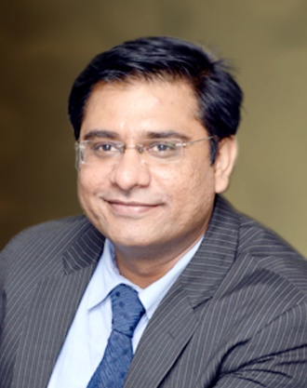

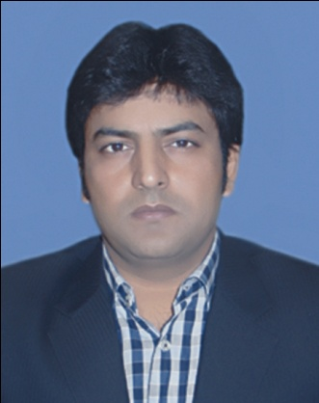





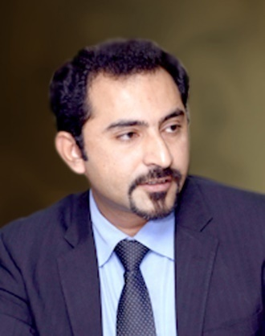

|  |  |  |  |  |
| --- | --- | --- | --- | --- |
| Name of officer | ADNAN SHAHID | | | |
| Current Posting | DCIR, UNIT-1 (E&C), ZONE-IV | | CTP | 37th |
| Education Qualification | MBA, MA | | STP | 37th |
| Date/year of posting in LTU | 15-08-2013 | Experience | | 5 Years |

|  |  |  |  |  |
| --- | --- | --- | --- | --- |
| Name of officer | MUHAMMAD KASHIF KHAN | | | |
| Current Posting | DCIR, UNIT-3 (E&C) ZONE-IV | | CTP | 37th |
| Education Qualification | B.E. (Electrical) | | STP | 37th |
| Date/year of posting in LTU | August, 2013 | Experience | | 5 Years |

|  |  |  |  |  |
| --- | --- | --- | --- | --- |
| Name of officer | BIRJEES SAGHEER | | | |
| Current Posting | DCIR, UNIT-1(AUDIT) ZONE-IV | | CTP | 38th |
| Education Qualification | Master (Prevous) | | STP | 38th |
| Date/year of posting in LTU | 06-09-2013 | Experience | | 4 Years |

|  |  |  |  |  |
| --- | --- | --- | --- | --- |
| Name of officer | UMAIR AKBAR SOOMRO | | | |
| Current Posting | ACIR, UNIT-1(AUDIT) ZONE-II | | CTP | 38th |
| Education Qualification | M.A. (Economics) B.C.I.T. | | STP | 38th |
| Date/year of posting in LTU | March 2014 | Experience | | 4 Years |

|  |  |  |  |  |
| --- | --- | --- | --- | --- |
| Name of officer | SHARJEEL AHMED | | | |
| Current Posting | ACIR, UNIT-4(E&C) ZONE-III | | CTP | 33th |
| Education Qualification | Computer Software Engg. | | STP | 39th |
| Date/year of posting in LTU | September, 2013 | Experience | | 9 Years |

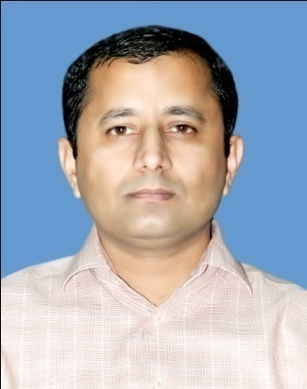

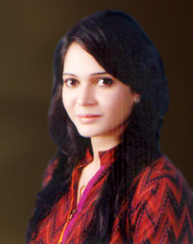

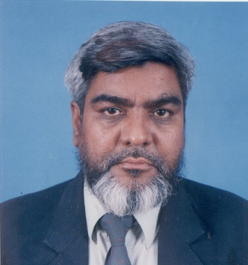

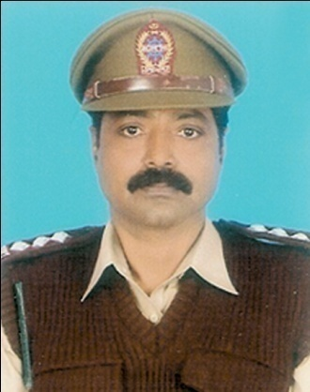

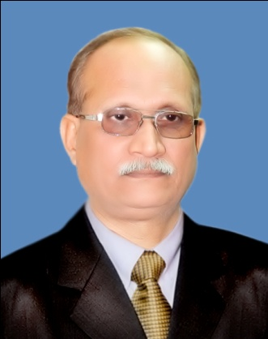

|  |  |  |  |  |
| --- | --- | --- | --- | --- |
| Name of officer | ABDUL HAMEED MANGIO | | | |
| Current Posting | Zone-III, LTU, Khi | | CTP | 39th |
| Education Qualification | M.S (Management)  B.E (Engg.) | | STP | 39th |
| Date/year of posting in LTU | 22-09-2014 | Experience | | 3 years |

|  |  |  |  |  |
| --- | --- | --- | --- | --- |
| Name of officer | FARAH YAMIN KHAN | | | |
| Current Posting | ACIR, Unit-4 (E&C), Zone-IV | | CTP | 40th |
| Education Qualification | LLB (LSE UK) Bar-at-Law (Lincoln’s Inn, UK)  Master in Public Policy (Harvard University, USA) | | STP | 40th |
| Date/year of posting in LTU | September, 2014 | Experience | | 2 years Corporate Law |

|  |  |  |  |  |
| --- | --- | --- | --- | --- |
| Name of officer | NIAZ ALAM | | | |
| Current Posting | IRO, UNIT-2(E&C) ZONE-II | | CTP | - |
| Education Qualification | B.Com, LLB | | STP | - |
| Date/year of posting in LTU | September, 2002 | Experience | | 37 Years |

|  |  |  |  |  |
| --- | --- | --- | --- | --- |
| Name of officer | M. PERVEZ KHAN | | | |
| Current Posting | IRO, UNIT-3 (E&C) & LEGAL Z-I | | CTP | N/A |
| Education Qualification | B.A | | STP | N/A |
| Date/year of posting in LTU | JANUARY, 2009 | Experience | | 33 YEARS |

|  |  |  |  |  |
| --- | --- | --- | --- | --- |
| Name of officer | MUHAMMAD ASHFAQ AHMED | | | |
| Current Posting | IRO/SO, ZONE-II | | CTP | - |
| Education Qualification | M.Sc (Maths) | | STP | - |
| Date/year of posting in LTU | JANUARY, 2009 | Experience | | 30 Years |

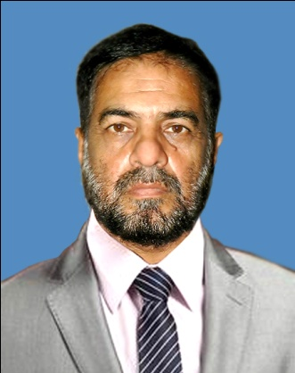

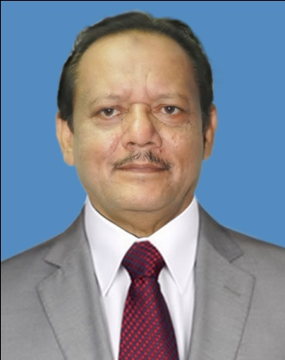

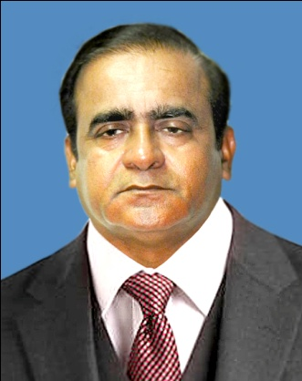

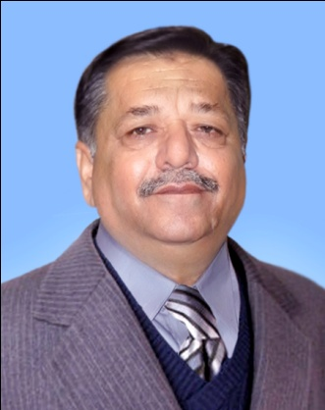

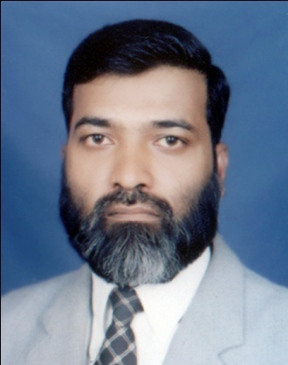

|  |  |  |  |  |
| --- | --- | --- | --- | --- |
| Name of officer | MUHAMMAD RAFIQ AWAN | | | |
| Current Posting | IRO, UNIT-2(E&C) ZONE-IV | | CTP |  |
| Education Qualification | B.Com, LLB | | STP |  |
| Date/year of posting in LTU | 20-09-2008 | Experience | | 36 Years |

|  |  |  |  |  |
| --- | --- | --- | --- | --- |
| Name of officer | M SHAHAB AKHTAR | | | |
| Current Posting | IRO, UNIT-3(E&C) ZONE-III | | CTP | - |
| Education Qualification | B.Com, LLB | | STP | - |
| Date/year of posting in LTU | January, 2004 | Experience | | 32 Years |

|  |  |  |  |  |
| --- | --- | --- | --- | --- |
| Name of officer | KHALID SIDDIQUI | | | |
| Current Posting | IRO, UNIT- ( ) ZONE-I | | CTP | - |
| Education Qualification | B.Com, LLB | | STP | - |
| Date/year of posting in LTU | February, 2005 | Experience | | 34 Years |

|  |  |  |  |  |
| --- | --- | --- | --- | --- |
| Name of officer | ASIM KHAN | | | |
| Current Posting | IRO, UNIT-3(E&C) ZONE-II | | CTP | - |
| Education Qualification | B.Com, MA | | STP | - |
| Date/year of posting in LTU | 2008 | Experience | | 34 Years |

|  |  |  |  |  |
| --- | --- | --- | --- | --- |
| Name of officer | ABDUL AZIZ | | | |
| Current Posting | DEO/SO Librarian Confrences | | CTP | N/A |
| Education Qualification | B.A | | STP | N/A |
| Date/year of posting in LTU | July, 2002 | Experience | | 26 Years |

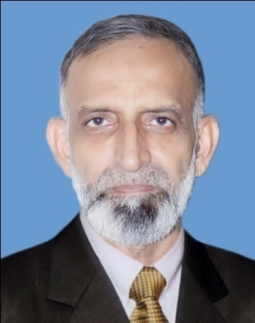

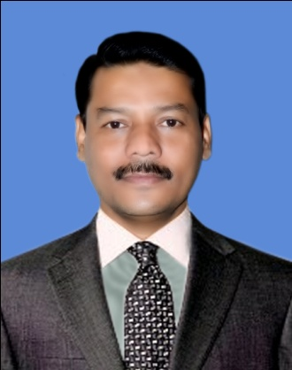

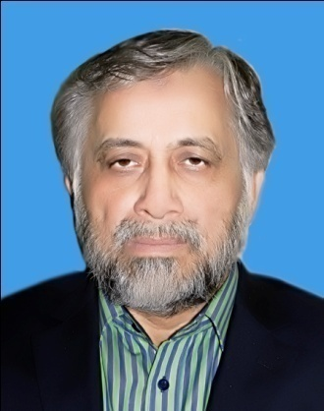

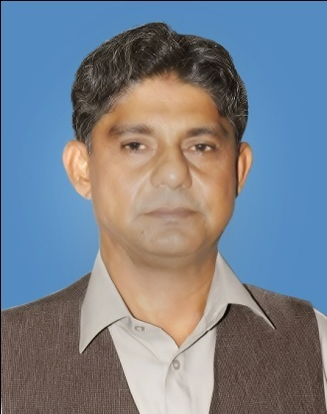

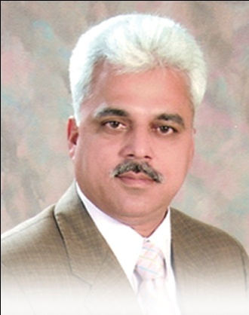

|  |  |  |  |  |
| --- | --- | --- | --- | --- |
| Name of officer | SHAHID ASIF SIDDIQUI | | | |
| Current Posting | Staff Officer DT/Legal | | CTP | N/A |
| Education Qualification | B.Com, ICMA (Part-I), IMM (Part-I) | | STP | N/A |
| Date/year of posting in LTU | 24-01-2004 | Experience | | 32 Years |

|  |  |  |  |  |
| --- | --- | --- | --- | --- |
| Name of officer | ZAFAR SIDDIQUI | | | |
| Current Posting | Staff Officer (Rev.Bud/WHT) | | CTP | N/A |
| Education Qualification | M.A. (Economics) | | STP | N/A |
| Date/year of posting in LTU | 2002 | Experience | | 22 Years |

|  |  |  |  |  |
| --- | --- | --- | --- | --- |
| Name of officer | ZIA KHAN | | | |
| Current Posting | Staff Officer (ST &FED)CCIR | | CTP | N/A |
| Education Qualification | B.Sc | | STP | N/A |
| Date/year of posting in LTU | Feb, 2009 | Experience | | 34 Years |

|  |  |  |  |  |
| --- | --- | --- | --- | --- |
| Name of officer | WAJIHUDDIN AHMED | | | |
| Current Posting | Private Secretary to  Chief Commissioner IR | | CTP | N/A |
| Education Qualification | M.A. (Economics) | | STP | N/A |
| Date/year of posting in LTU | 2003 | Experience | | 34 Years |

|  |  |  |  |  |
| --- | --- | --- | --- | --- |
| Name of officer | TANVEER AHMED AWAN | | | |
| Current Posting | Staff Officer  (PROTOCOL & SECURITY) | | CTP | N/A |
| Education Qualification | B.A. | | STP | N/A |
| Date/year of posting in LTU | 2004 | Experience | | 22 Years |